MAINTENANCE PROGRAM
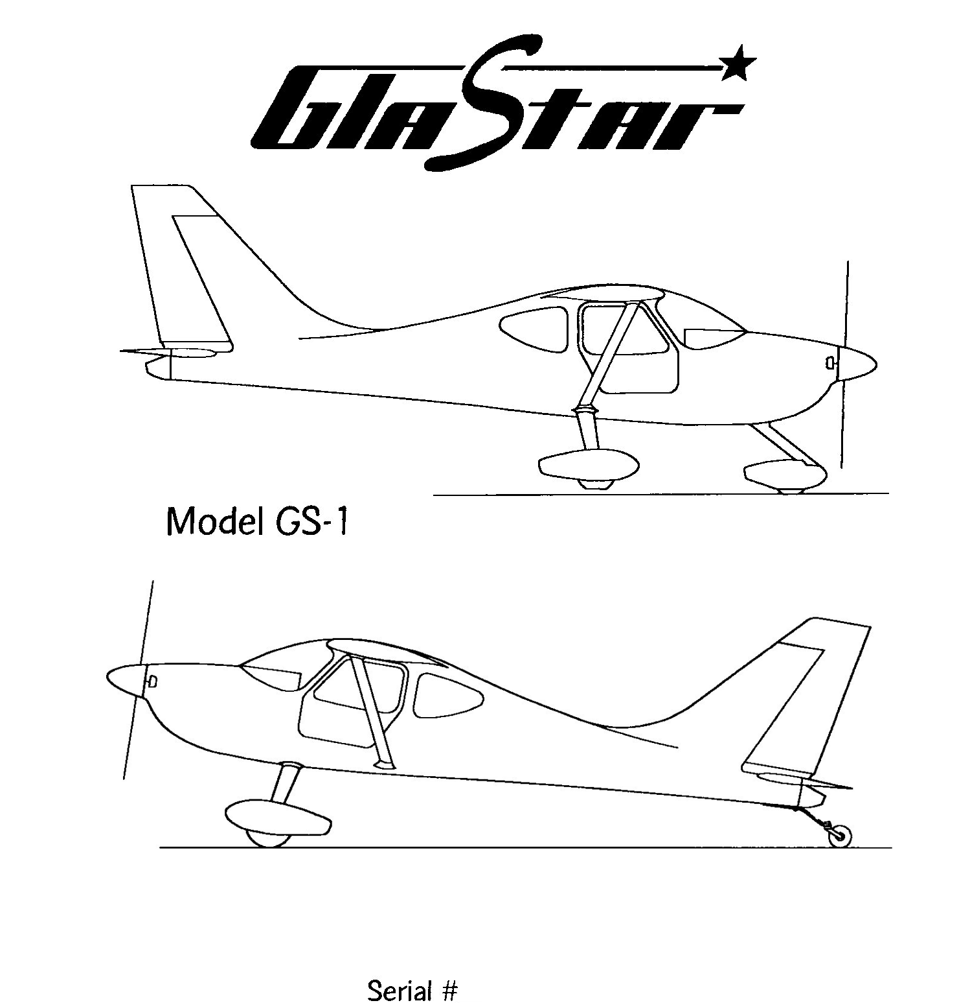

5083

Registration: HB – YMQ

The aircraft maintenance must be carried out in accordance to the specified items in this maintenance manual.
THIS AIRCRAFT MAINTENANCE PROGRAM IS APPROVED BY EAS SWITZERLAND,
By order of FOCA, Federal Office of Civil Aviation, Bern

DATE: …………………… Visum: ……………………………

XX.9 Attachments

9.1 List of attachments of Aircraft -Manual

attachement nr. object origin date

Maintenance | M1 – 2 | Maintenance Program index | 08/2008
Maintenance | M1 – 3 | Maintenance Program general | 08/2008
Maintenance | M1 – 4 | Maintenance Program 50 hr | 08/2008
Maintenance | M1 – 5 | Maintenance Program 50 hr | 08/2008
Maintenance | M1 – 6 | Maintenance Program 100hr/an. | 08/2008
Maintenance | M1 – 7 | Maintenance Program 100hr/an. | 08/2008
Maintenance | M1 – 8 | Maintenance Program 100hr/an. | 08/2008
Maintenance | M1 – 9 | Maintenance Program 100hr/an. | 08/2008
Maintenance | M1 – 10 | Maintenance Program 100hr/an. | 08/2008
Maintenance | M1 – 11 | Maintenance Program 100hr/an. | 08/2008
Maintenance | M1 – 12 | Maintenance P. restricted parts | 08/2008
Maintenance | M1 – 13 | Maintenance Prog. liquids/parts | 08/2008
1 | SB 33 | Exhaust System Inspection | 24/09/1997
2 | SB 49 | Fuselage Cage Inspection | 02/02/2004

Maintenance program

Aircraft: GLASTAR GS-1 HB-YMQ serial number 5083 TSN : ______

Date: ________________________________ TSO : ______

Prior to the inspection the following documents have to be available: aircraft manual, log book, technical logs, airworthiness directives (LTA) and technical memos (TM) of the FOCA. Further for the engine service bulletin 33 from NewGlastar and for an annual service bulletin 49.

Any kind of complaints (Owners Manual or equivalent) has to be accounted for.

Prior to inspection the aircraft and the engine have to be thoroughly cleaned. All control covers and fairings have to be removed or opened.

Annual minimum maintenance must be performed
according to FOCA TM-W F 02.020-10 as a
complete 100 h control.

With x marked issues have to be controlled by approaching a certain number of operating hours

X |  | 50 | 100 | annual

Maintenance Program

INSPECTION CHECKLIST

This inspection is in accordance with the Lycoming engine Operator's Manual.

Engine Group (50 Hours)

GENERAL ENGINE COMPARTMENT

Check fuel and oil line connections and repair any leaks. Make sure that the cowling and baffling are in good condition and securely mounted. Any damaged or missing part of the cooling system must be replaced before the aircraft resumes operation. Inspect and service the air filter.
50 h
Fuel and oil line connections
Check cowling and baffling for damage and secure anchorage
Check cooling path
Inspect and service air filter

IGNITION SYSTEM

If spark plug fouling has been apparent, rotate the lower plugs to the upper position and move one cylinder. Examine the spark plug cable leads and the spark plug ceramics for corrosion and deposits. This condition is evidence of either leaking spark plugs or improper cleaning of the spark plug walls or connector ends. Where this condition is found, clean with alcohol. All parts should be clean and dry before reassembly.
Check the ignition harness for security of the mounting clamps and make sure all connections are tight and properly torqued at the spark plug and magneto terminals.
50 h
Check spark plugs for fouling
Inspect spark plug leads of cable and ceramics for corrosion and deposits
Check ignition harness

FUEL AND INDUCTION SYSTEM

Check the primer lines for leaks and security of clamps. Remove and clean the fuel-inlet strainers. Check the mixture, throttle and carb heat control linkages for travel, freedom of movement and security of clamps; lubricate if necessary. Check the air intake duct (carb heat valve) for leaks and security.
Remove and inspect the air filter element. For the Bracket air filter used with the Lycoming induction system, replace the element after 200 hours of use or every 12 months or when it is difficult to see light through it due to foreign material. Clean with compressed air; do not wash and reuse. These filters are chemically treated to make them more effective.
50 h
Check the primer lines
Remove and clean the carburetor fuel-inlet strainers
Check the mixture, throttle and carb heat control linkages for travel, freedom of movement and security of clamps, lubricate if necessary.
Check the air intake duct (carb heat valve) for leaks and security.
Remove and inspect the air filter element.
Clean the bracket air filter (or replace after 200 hours or every 12 months
or when it is clogged).
Check vent lines for evidence of fuel or oil seepage (may require replacement)

OIL SYSTEM

If your engine is due for an oil change (see NOTE below), drain the crankcase oil and then replace and safety-wire the drain plug, Replace the external, full-flow oil filter element, We recommend opening the old filter with an oil filter can cutter to inspect for metal particles that might indicate engine damage, optional let a spectral analysis do. SPECTRO OIL AG, Rinaustr. 452 4303 Kaiseraugst, +41 61 815 90 20.
50 h
Check vent lines for evidence of fuel or oil seepage (may require replacement)
Check all oil lines for leaks, chafing, dents or cracks.
Refill the engine with fresh oil.
Replace external oil filter element.
Drain and renew lubricating oil.

NOTE
For Lycoming engines, intervals between oil changes can be increased by at least 100% on engines equipped with full-flow oil filters. This increase in oil change interval is recommended only if an air filter is also installed. For Lycoming engines, see Service Instruction 1319 B for further details.

Check all oil lines for leaks, chafing, dents or cracks. Refill the engine with fresh oil.

EXHAUST SYSTEM

Check the attaching flanges at the exhaust ports on the cylinders for evidence of leakage. Examine the exhaust manifold for general condition. Inspect for cracks, especially in the cabin heat muff area. Soot on the inside surface of the heat muff shroud indicates the presence of cracks. Any cracks must be repaired by welding before further flight. See SB 33!

WARNING
Stainless steel exhaust systems must be repaired by qualified personnel using special methods to prevent contamination of the metal during welding, otherwise cracking may persist.

25 h 50 h
Check attaching flanges at exhaust ports on cylinders for leakage.
Examine the exhaust manifold for general condition.
Inspect for cracks, especially in the cabin heat muff area. (SB 33)

CYLINDERS

Check the rocker box covers for evidence of oil leaks. If leaks are found, replace the gaskets and tighten the screws to 50 inch-pounds.
Check the cylinders for cracked cooling fins and for excessive heat, indicated by burned paint on the cylinder. Excessive heat is indicative of internal damage to the cylinder; if found, its cause must be determined and corrected before the aircraft resumes operation.
50 h
Check the rocker box covers for evidence of oil leaks.
If leaks are found, replace the gaskets and tighten the screws to 50 inch-pounds
Check cylinders for cracked cooling fins and for excessive heat

ANNUAL CONDITION INSPECTION

The service and inspection procedures described below must be performed annually in accordance with the scope and detail of FAR Part 43, Appendix D. If the aircraft is found to be in a condition for safe operation, a proper entry must be made in the airplane's log book by an authorized person (the original builder or a licensed A&P mechanic), certifying the condition of the airplane.
The following checklist is intended as a guide and is not represented to be complete. It is the responsibility of the operator and repairman to inspect and maintain the entire aircraft in an airworthy condition.

2.1 PROPELLER MAINTENANCE (Prince fix Pitch 78”)

Annual/100 Hour Inspection

Remove spinner
Ann./ 100h
Inspect blades and centre for, nicks, cracks
Check visible parts for wear and safety
Check propeller bolt torque 500 inch-pounds
Check accuracy of tachometer
Make entry in logbook to verify inspection

Airworthness Limitations
Ann./ 100h
Check for life limited components

2.2 POWERPLANT

Engine Run-up: start the engine and warm it up thoroughly.

Check the following: Ann.
1 Oil pressure
2. Alternator output.
3. Left magneto drop.
4. Electroair Ignition drop.
5. Static r.p.m.
6. Idle r.p.m.
7. Carburetor heat.
8. Magneto ground.
9. Mixture cut-off r.p.m. rise at idle.

B. Engine Inspection and Service:

1. Remove the engine cowling and check for leaks and stains.
2. Perform a compression check. Record the results in the engine log book.
3. Drain the oil, replace the filter.
4. Clean and safety-wire the suction port.
5. Refill the crankcase with fresh oil.
6. Check carburettor drain plug.
7. Clean and adjust the spark plugs; rotate upper and lower plugs move one cyl.
8. Check the ignition harness for breaks; check the cigarettes and contact springs.

C. Magnetos:

1. When replacing, lubricate the breaker cam follower.
2. When replacing, check the point gap and the condition of the points.
3. Check the P-leads for breaks, frays.
4. Check and adjust the Electroair and magneto timing.

D. Engine Controls:

Check the following controls for security, full range of travel, chafing, safety. Lubricate if necessary.
Ann.
1. Throttle.
2. Mixture.
3. Carburetor heat.
4. Cowl flaps.

E. Battery Inspection: Ann.

1. Clean the battery terminals and check condition.
2. Check cable for attachement and security.
3. Make a capacity test report capacity ____ %

F. General Engine Compartment and Engine Accessories: Ann.

1. Inspect the alternator: mounting, wiring, terminals.
2. Inspect the alternator belt and adjust its tension, if needed.
3. Inspect the starter: wiring, terminals, brushes.
4. Lubricate the starter engage gear with teflon/silicon spray
5. Remove cabin heat muff and check exhaust system for cracks.
6. Check the exhaust pipes, muffler, gaskets and shrouds for security and cracks.

NOTE
GlaStar Service Bulletins 33 prescribe specific inspection requirements for the
exhaust systems installed on Lycoming engines with Dynafocal mounts.

7. Check the cylinder baffles for cracks and proper seal.
8. Check the rocker box covers for evidence of oil leaks, check screws.
9. Check engine mount for security, rust, chafing and condition of rubber bushings.
10. Check the engine for loose nuts, bolts and screws.
11. Check the oil cooler and lines for security, chafing and obstructions.
12. Check the primer system for leaks.
13. Check all breather and overboard lines for security and obstructions.
14. Inspect fuel filter element and replace if necessary. Safety wire fuel filter bowl.
15. Clean the carburetor screens and check the fuel flow.
16. Inspect the carburetor or injector and the fuel lines for security and leaks.
17. Inspect the cabin heat muff, heat valve and hoses for security and leaks.
18. Inspect the carburetor heat box, damper and hoses for condition and operation.
19. Remove propeller spinner,check spinner, front + back plate for security and cracks.
20. Inspect propeller track. Check blades for nicks. Reinstall the spinner.
21. Inspect the induction air filter and clean. Replace if clogged due to foreign material
or if it has been in service for 12 months or 200 hours since last replacement.
22. Inspect all engine compartment wiring for security, cracked or brittle insulation and
chafing. Check especially the starter and alternator wiring for security and tight
connection. Replace any nylon tie wraps or spiral wrap that is brittle or discoloured.
23. Wash the engine and cowling, using a suitable solvent or engine degreaser.
24. Check the cowling for chafing, cracks or heat damage.
25. Check the engine for any loose hardware and tools that may have been left in engine
compartment during maintenance.

G. Ground Run-up Check (log and record): Ann.

1. Oil pressure.
2. Alternator output.
3. Left magneto drop.
4. Electroair Ignition drop.
5. Static r.p.m.
6. Idle r.p.m.
7. Carburetor heat.
8. Magneto ground.
9. Mixture cut-off r.p.m. rise at idle.
10. After engine shut-down, check for oil leaks.
11. Reinstall the lower cowling and check the operation of the landing light.

2.3 CABIN, FUSELAGE AND EMPENNAGE

Remove the glare shield, forward control cable covers, seat pan inserts, baggage compartment bulkhead, baggage floor, tail fairings, horizontal stabilizer and forward and aft inter-bulkhead shearwebs, as necessary.

Inspect the following: Ann.

A. Inspect the control system cables, pulleys, pushrods and rod-end bearings for
corrosion, safety, security and chafing. Lubricate all pivot points, bearing sur-
faces and pulleys as necessary. Check the following systems:
1. Aileron system.
2. Elevator system.
3. Rudder system.
4. Flap system.
5. Trim system.
B. Inspect the rudder pedal weldments, control stick pivot brackets and aileron/
elevator control yoke for excessive play. Tighten or replace any excessively
loose bolts.
C. Check the operation of the fuel selector valves. Check the valve markings.
D. Check all fuel lines for leaks, security and chafing.
E. Drain the fuel tank sumps and check for contaminants. Remove and clean the
fuel sump strainers (finger screens) if excessive contamination is apparent.
F. Check the instruments for security, legibility and markings.
G. Check the fuel tank gauges for proper markings, indication and freedom
of movement.
H. Check compass for discoloration and compass correction card displayed.
I. Check the circuit breaker, fuses and switches for security and condition.
- Check all instrument wiring and plumbing for security and chafing. Replace
any nylon tie wraps or spiral wrap that is brittle or discoloured.
- Check radio equipment, wiring and antennas.
- Check all plexiglas for cracks.
- Check landing gear attach bolts.
- Check the door hinges and latches. Lubricate as required.
- Inspect the fuselage cage welds for cracks or stress marks.(SB49)
- Check the static ports and the pitot/static plumbing.
- Check the seat pans (insert and border) for cracks or stress marks.
- Check the seat belts and shoulder harnesses for security and condition.
- Check brake master cylinders and brake line fittings for leaks. Check parking
valve. Check brake lines for security.
- Top up the brake fluid reservoir, leaving an air space for fluid expansion.
- Check all fuselage to cage attach screws.
- Check stabilizer, elevator, rudder and trim tab for dents, cracks, corrosion and
loose rivets.
- Check the security of stabilizer alignment pins, aft stabilizer attach bracket.
- Check the empennage counterweights for cracks, security and chafing.
- Check and lubricate the elevator, rudder and trim tab hinges. Verify that the
hinges are properly safe tied.
- Check all aft-fuselage bulkheads for integrity. Check security of the forward
stabilizer attach bracket and aft stabilizer attach nut plates.
- Reattach the stabilizer. Reattach the elevator pushrod and the trim system.
- Check the elevator and the rudder for proper travel:
1. Elevator: 23° up and 20° down (±1°)
2. Rudder: 25° left and right (±1°)

2.4 LANDING GEAR Ann.

A. Check the backing plates holding brake callipers for cracks and security.
C. Check the landing gear struts for general condition.
D. Check the landing gear support structure for evidence of damage. Check the
main and tail wheel strut-attach hardware for security and integrity.
E. Check the tires for cracks, wear and proper inflation.
F. Repack the wheel bearings and inspect the wheels for cracks and corrosion.
Lubricate the tail wheel pivot.
G. Check the brake mounting flanges for tightness and security.
G1. Replace attach bolts if worn. Replace flange weldment if holes are elongated.
H. Inspect the brake discs for excessive scoring, the brake lines for leaks or chafing
and the brake pads for wear. Replace the brake pads, if necessary, Check the
operation of the brakes. If the brakes feel soft or spongy, bleed them.
J. Check the tail wheel steering linkage for security and integrity.
K. Check for loose hardware and tools in the fuselage and tail areas.
L. Vacuum the cockpit area. Clean the windshield and the canopies.
M. Reinstall the interior panels, the tail fairings and the landing gear fairings.

2.5 WINGS Ann.

A. Remove all inspection covers and the wingtip fairings.
B. Check the wing attach pins, bolts and fittings for security, integrity and safety.
C. Check wing and control surface skins for cracks, dents, corrosion, loose rivets.
D. Check the wingtip fairings for cracks and stress marks.
E. Check all wiring and plumbing for chafing and security.
F. Check all aileron and flap control cables, pushrods, rod-ends, bellcranks and
hinges for corrosion, safety, security and chafing. Lubricate pivot points surfaces
and bearing as necessary.
G. Check the ailerons for proper travel: 22.5° up and 17.5° down (±1°).
H. Make sure the flap guide-arm bearings contact the ends of the flap track slots in
the fully retracted and extended flap positions. Check the roller bearings for wear
and replace if necessary.
I. Inspect the aileron counterweights for integrity, security and chafing. (Be sure
any wiring in the wing tips can not jam the aileron counterweights.)
J. Check the fuel tanks and fuel tank fittings for leaks. Check the fuel lines and
vent lines for integrity and freedom from chafing.
K. Check the navigation and anti-collision lights for secure mounting.
L. Check the fuel filler caps for proper labelling.
M. Check the pitot tube for security. If a heated pitot tube is installed, make sure
the drain hole is clear. Check the pitot line for integrity and freedom from chafing.
N. Check inside the wings for loose hardware and tools.
O. Reinstall the wingtip fairings and check the operation of the
navigation and anti-collision lights.
P. Reinstall the inspection covers.

2.6 PAPERWORK Ann.

Make sure the following documents are present, current and properly displayed:
A. Airworthiness certificate.
B. Liability insurance certificate.
C. Operating limitations (issued by the EAS in behalf of the FOCA) AFM Chap. 2
D. Weight and balance, AFM Chap. 6
E. Placards, AFM Chap 2
F. Radio station license
G. The Owner's Manual/AFM.
H. Any ADs/LTAs for Avionic enter in the according papers.
I. Log book, technical logs: make a log book entry, noting any discrepancies and
other pertinent information. Sign off the annual condition inspection as required
by the operating limitations imposed with your Airworthiness Certificate.

OTHER PARTS WITH RESTRICTED OPERATING HOURS

Interval

Engine (overhaul) on condition
Propeller (overhaul) on condition
Engine accessories (overhaul) on condition
Hoses engine (replacement) on condition
air filter (replacement) 200 hrs or 12 months
Magnetic compass check every 2 years
Encoder x-ponder (Gilham) test every 2 years

Any parts of the aircraft not being mentioned in this manual must be overhauled or replaced in accordance with status and requirements.

50/hr 100/hr annual control done:

Date:___________________________________________

Sign:____________________________________________

LIQUIDS/PARTS/PRESSURES

Fuel: AVGAS 100 LL
Super Plus ROZ 98

Oil: SAE 40-50
max 8 quarts / min 2 quarts
Filter Champion CH48110

Hydraulic oil, Brake system: MIL-H-5606BB

Spark Plugs: Champion REM 38E

Air Filter (different manufacturer): New Glastar P/N 620-0110-001
Brackett aero filter BA 110 (Filter BA23)
K&N E-1040
FRAM CA 148
PUROLATOR A 30057
AC Delco A 152C
FLEETGUARD AF 324
BALDWIN PA 657
WIX 42055
Robinson p/n A771-1

Landing Gear:

Main wheel inflation: 35-50 psi
Tailwheel inflation: 50 psi
Gear bearings: check for grease

